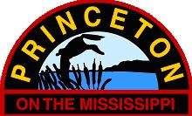

**THIS IS A LEGAL PUBLIC NOTIFICATION**
**DO NOT REMOVE**

CITY OF PRINCETON
311 3RD STREET
PO BOX 307
PRINCETON IA 52768
563-289-5315
princetoniowa.us
cityclerk@princetoniowa.us

PRINCETON CITY COUNCIL WILL MEET WITH THE NORTH SCOTT SCHOOL BOARD

THURSDAY, OCTOBER 12, 2023

5 P.M.

PRINCETON CITY HALL

AGENDA

A. ROLL CALL

B. NORTH SCOTT SCHOOL BOARD DISCUSSION

D. ADJOURNMENT

