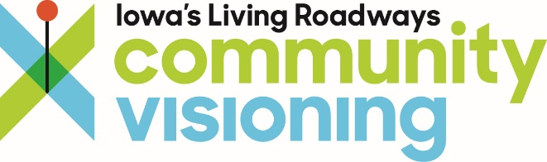

Tuesday, December 28, 2021

6:00 to 7:00 pm

Agenda
Princeton Community Visioning Steering Committee
Implementation Meeting

Location: Princeton City Hall
Facilitator: Molly Walkner – Trees Forever Field Coordinator

Meeting Topics
- Welcome & Introductions
  - Program Review
- Planning for Sustained Action
  - Roles and responsibilities
  - Committee structure and community involvement
- Project Prioritization
- Review funding opportunities – Community Funding Guide
  - https://treesforever.org/Community-Project-Funding-Guide/
- Questions & Comments
- Meeting Evaluation: https://iastate.qualtrics.com/jfe/form/SV_a8ItHpqYBJGw4Qd
- More Information: https://www.communityvisioning.org/princeton/

